Set 1: Monthly Sales Data
Experiment 1: Monthly Sales Line Chart
month <- c("January","February","March","April","May")
sales <- c(15000,18000,22000,20000,23000)
plot(sales,
type = "o",
col = "blue",
xaxt = "n",
xlab = "Month",
ylab = "Sales ($)",
main = "Monthly Sales Line Chart")
axis(1, at = 1:5, labels = month)
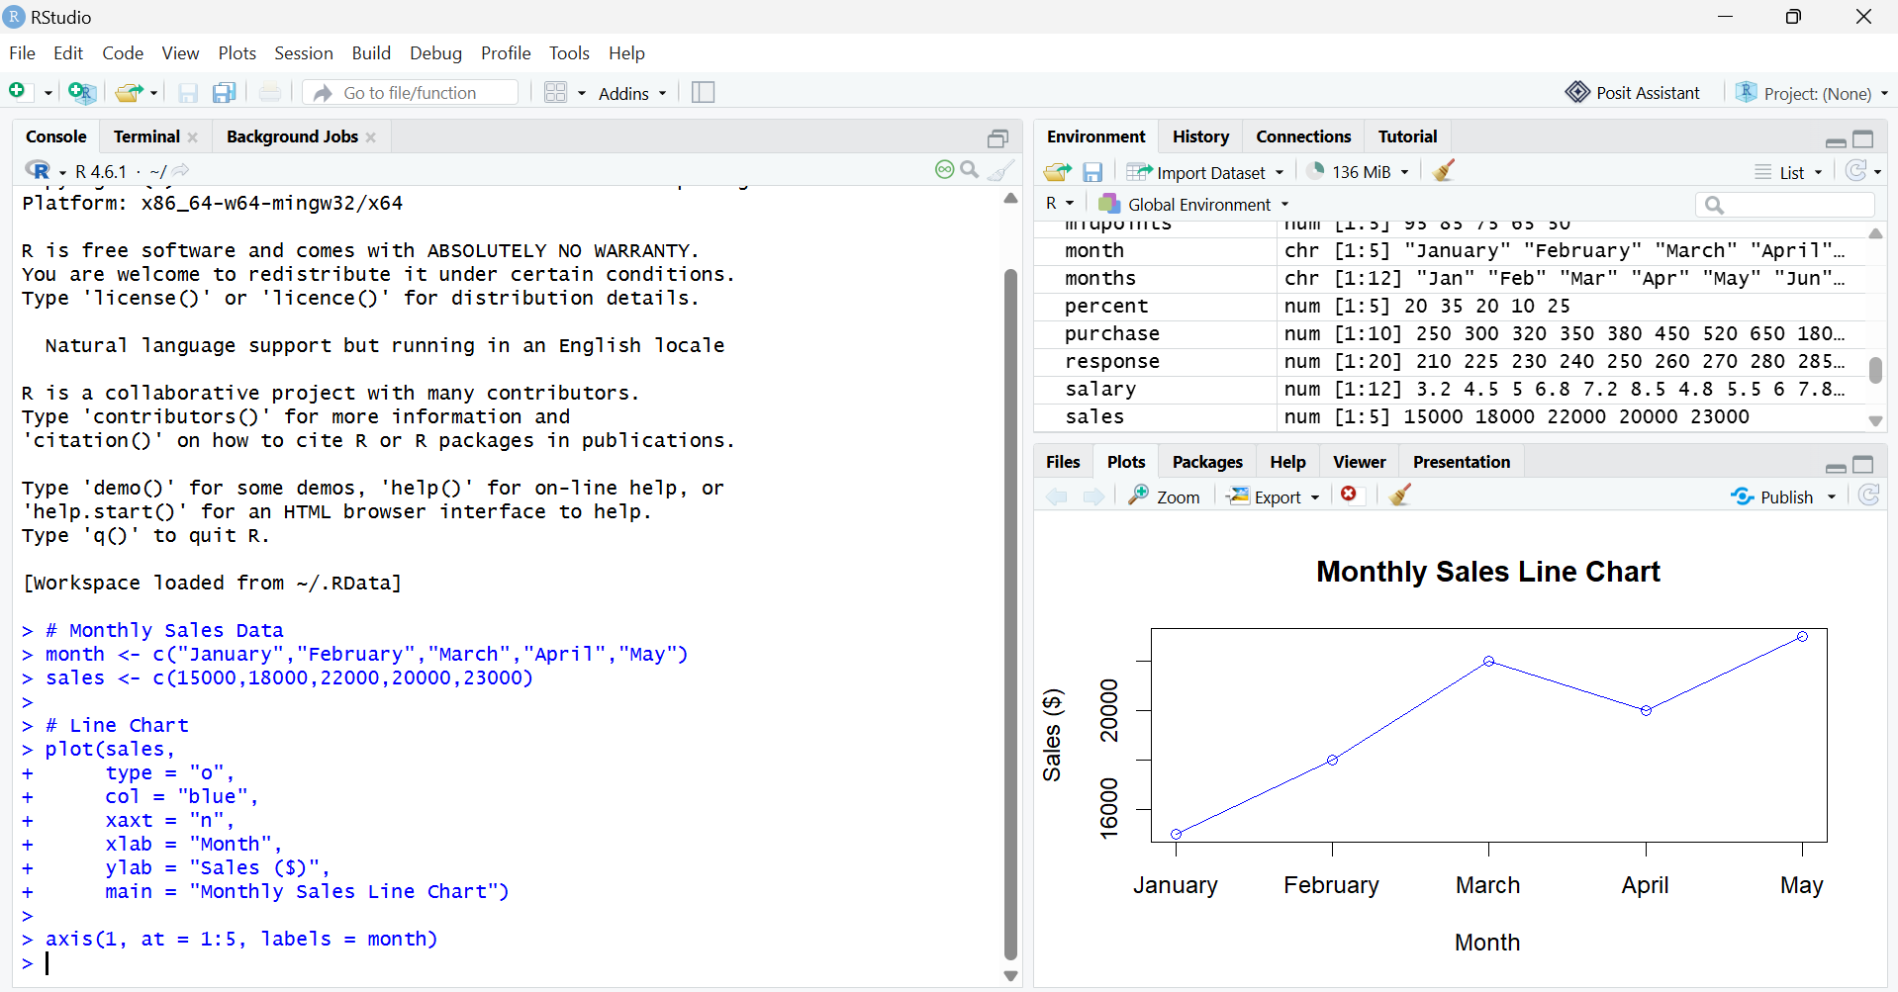

Experiment 2: Bar Chart – Top Selling Products
Month <- c("January", "February", "March", "April", "May")
Sales <- c(15000, 18000, 22000, 20000, 23000)
barplot(Sales,
names.arg = Month,
col = "skyblue",
xlab = "Month",
ylab = "Sales ($)",
main = "Monthly Sales Bar Chart")
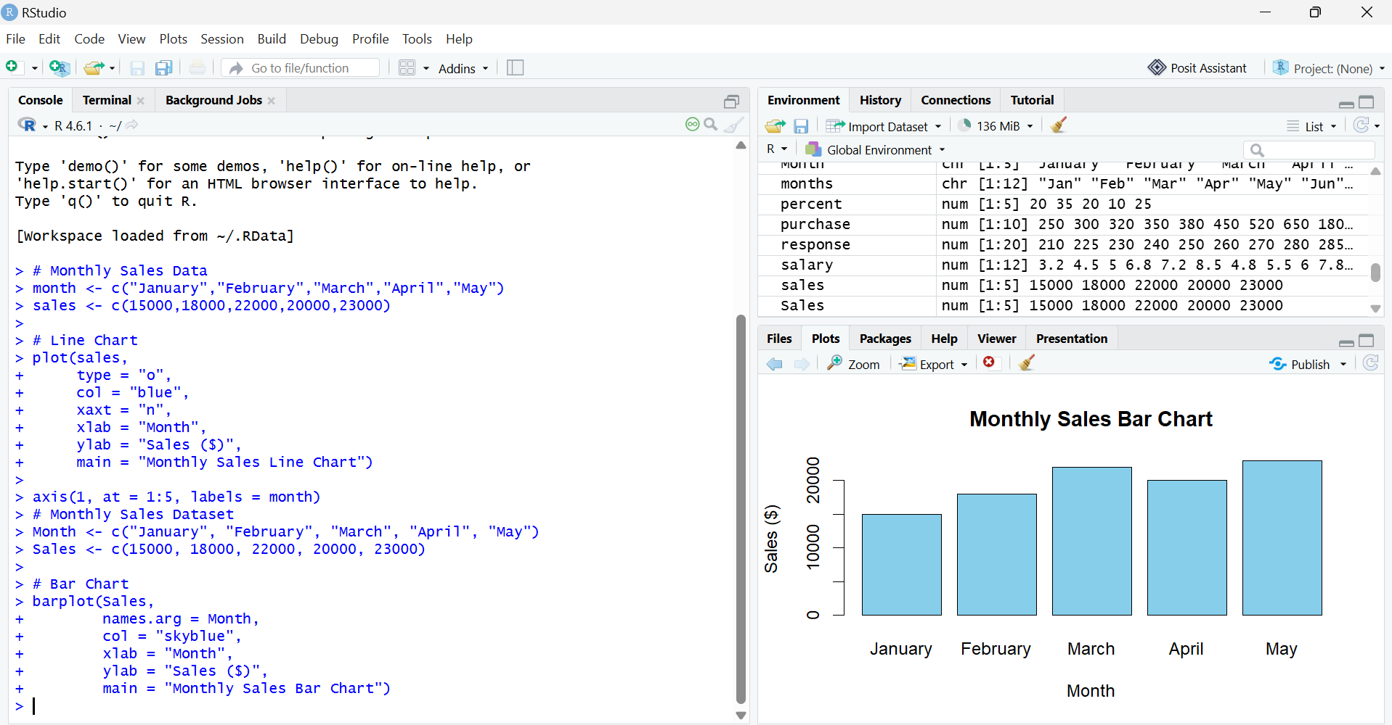

3. Scatter Plot (Advertising Budget vs Monthly Sales)
Month <- c("January", "February", "March", "April", "May")
Sales <- c(15000, 18000, 22000, 20000, 23000)
Advertising_Budget <- c(2000, 2500, 3000, 2800, 3500)
plot(Advertising_Budget,
Sales,
pch = 19,
col = "red",
xlab = "Advertising Budget ($)",
ylab = "Monthly Sales ($)",
main = "Advertising Budget vs Monthly Sales")
abline(lm(Sales ~ Advertising_Budget), col = "blue", lwd = 2)
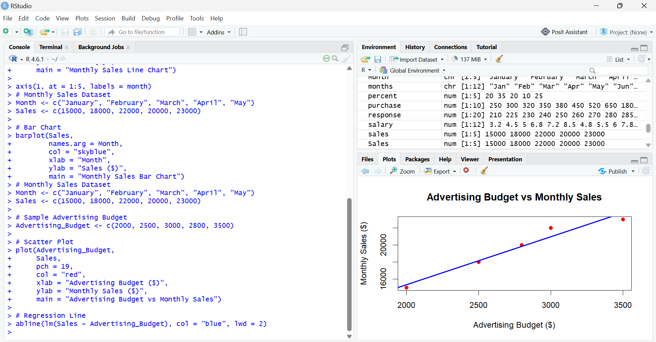

4. Interactive Dashboard (Flexdashboard)
Month <- c("January", "February", "March", "April", "May")
Sales <- c(15000, 18000, 22000, 20000, 23000)
par(mfrow = c(1,2))
plot(Sales,
type = "o",
col = "blue",
xaxt = "n",
xlab = "Month",
ylab = "Sales ($)",
main = "Monthly Sales Line Chart")
axis(1, at = 1:5, labels = Month)
barplot(Sales,
names.arg = Month,
col = "skyblue",
xlab = "Month",
ylab = "Sales ($)",
main = "Monthly Sales Bar Chart")
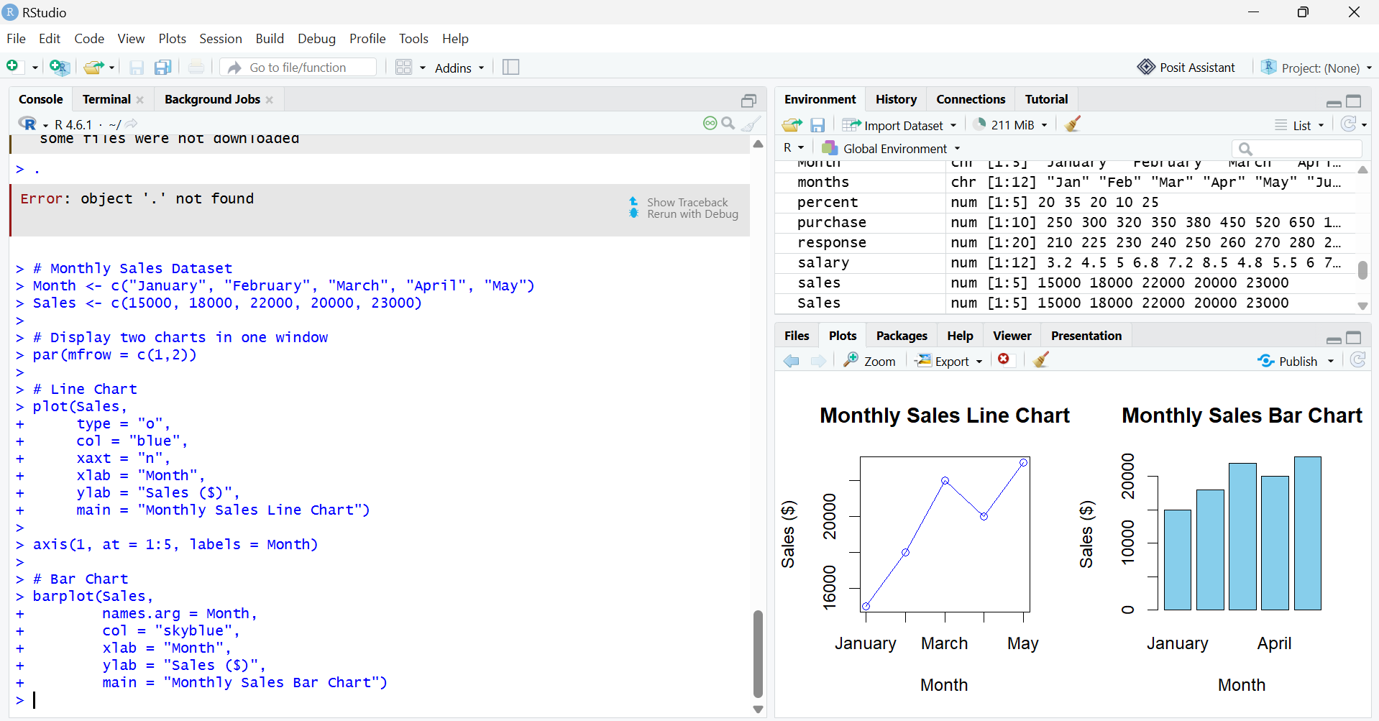

Set 2: Customer Feedback Analysis
Experiment 1: Histogram of Customer Ages
CustomerID <- c(1,2,3,4,5) Age <- c(25,30,35,28,40)
Satisfaction <- c(4,5,3,4,5)
customer_data <- data.frame(CustomerID, Age, Satisfaction) hist(customer_data$Age,
breaks = 5,
col = "lightblue",
main = "Distribution of Customer Ages", xlab = "Age",
ylab = "Frequency")
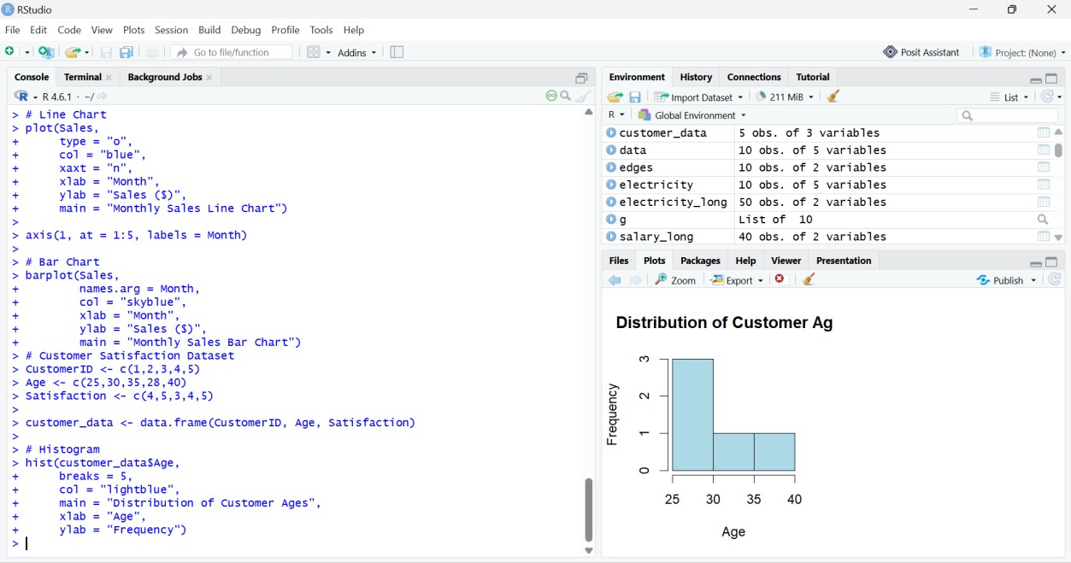

Experiment 2: Pie Chart of Customer Satisfaction Scores
CustomerID <- c(1,2,3,4,5) Age <- c(25,30,35,28,40)
Satisfaction <- c(4,5,3,4,5)
customer_data <- data.frame(CustomerID, Age, Satisfaction) score <- table(customer_data$Satisfaction)
pie(score,
= paste("Score", names(score)), col = c("pink","lightgreen","skyblue"), main = "Customer Satisfaction Scores")
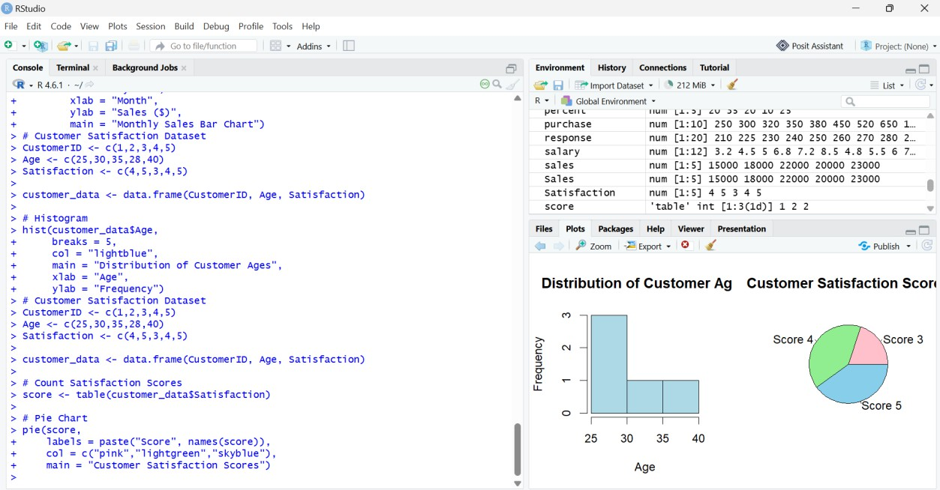

Experiment 3: Stacked Bar Chart
CustomerID <- c(1,2,3,4,5) Age <- c(25,30,35,28,40)
Satisfaction <- c(4,5,3,4,5)
customer_data <- data.frame(CustomerID, Age, Satisfaction) customer_data$AgeGroup <- ifelse(customer_data$Age <= 30,
"21-30","31-40")
data <- table(customer_data$AgeGroup, customer_data$Satisfaction)
barplot(data,
col = c("yellow","orange","green"),
main = "Customer Satisfaction by Age Group", xlab = "Age Group",
ylab = "Count") legend("topright",
legend = colnames(data,
fill = c("yellow","orange","green"), title = "Satisfaction")
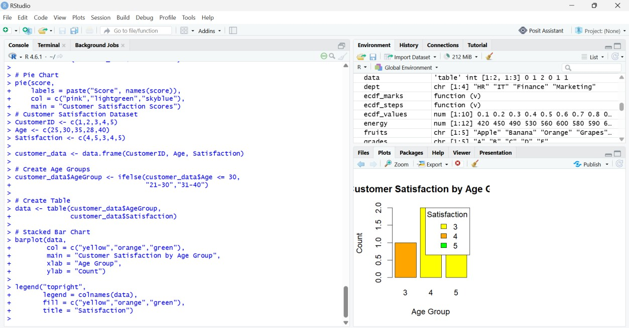

Experiment 4: Word Cloud install.packages("tm") install.packages("wordcloud") install.packages("RColorBrewer") library(tm)
library(wordcloud) library(RColorBrewer) feedback <- c(
"Good service and fast delivery", "Excellent product quality", "Very good customer support",
"Fast delivery and excellent service", "Good experience and quality product") docs <- Corpus(VectorSource(feedback))
docs <- tm_map(docs, content_transformer(tolower)) docs <- tm_map(docs, removePunctuation)
docs <- tm_map(docs, removeNumbers)
docs <- tm_map(docs, removeWords, stopwords("english")) tdm <- TermDocumentMatrix(docs)
m <- as.matrix(tdm)
word_freq <- sort(rowSums(m), decreasing = TRUE) wordcloud(
words = names(word_freq), freq = word_freq,
min.freq = 1, random.order = FALSE,
colors = brewer.pal(8, "Dark2"))

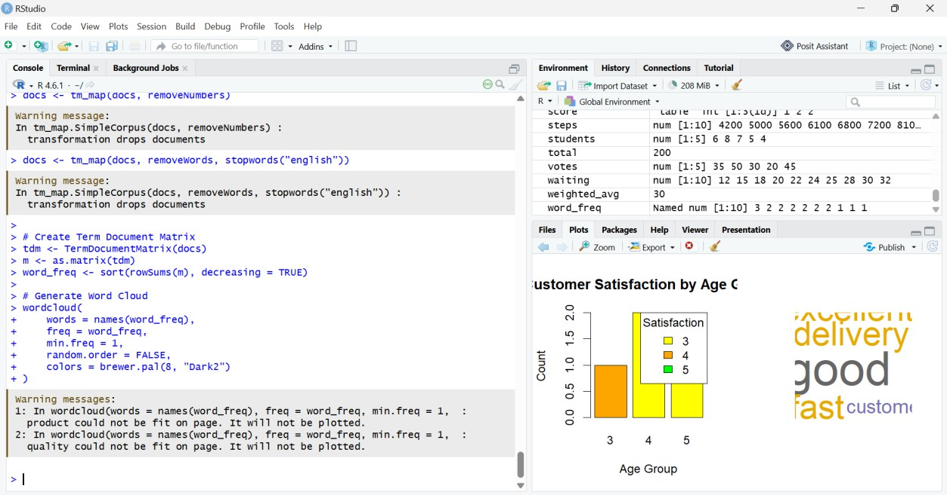

Set 3 – Employee Performance Evaluation
Q1. Line Chart
employee <- data.frame(
EmployeeID = c(1,2,3,4,5),
Department = c("Sales","HR","Marketing","Sales","HR"),
YearsService = c(5,3,7,4,2),
PerformanceScore = c(85,92,78,90,76))
plot(employee$EmployeeID,
employee$PerformanceScore,
type = "o",
pch = 16,
col = "blue",
xlab = "Employee ID",
ylab = "Performance Score",
main = "Employee Performance Trend")
legend("topright",
legend = "Performance Score",
col = "blue",
lty = 1,
pch = 16)
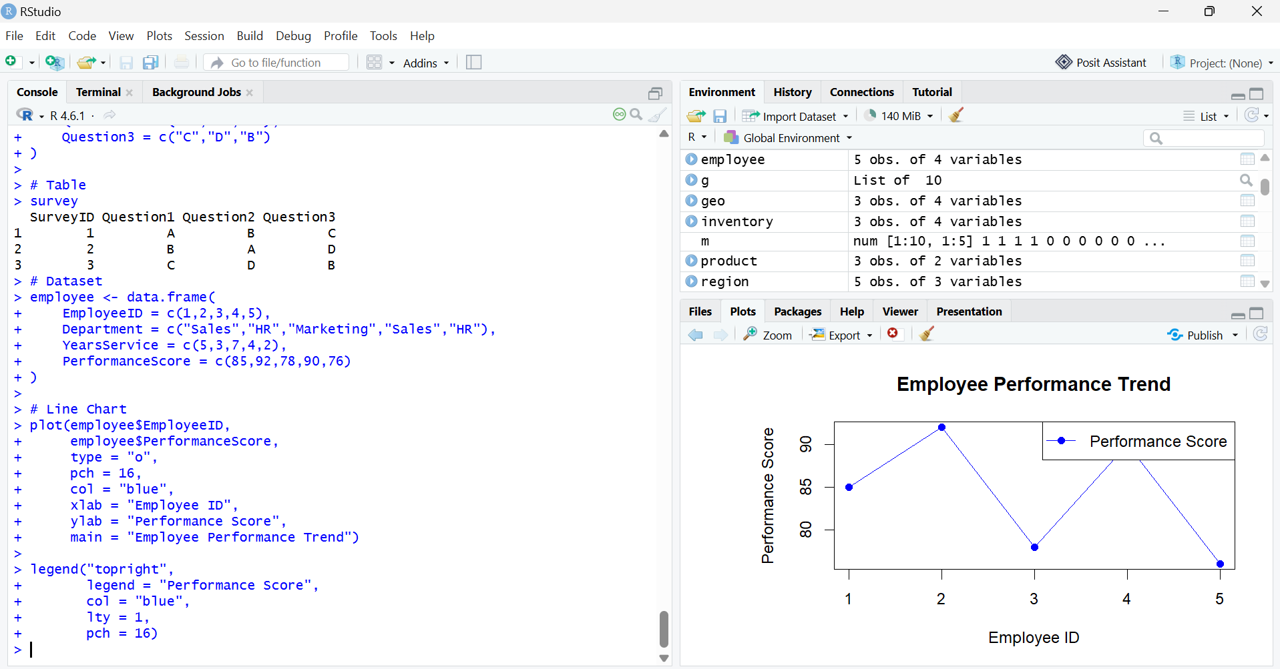

Q2. Bar Chart
employee <- data.frame(
EmployeeID = c(1,2,3,4,5),
Department = c("Sales","HR","Marketing","Sales","HR"),
YearsService = c(5,3,7,4,2),
PerformanceScore = c(85,92,78,90,76)
)
dept <- table(employee$Department)
barplot(dept,
col = c("skyblue","orange","lightgreen"),
xlab = "Department",
ylab = "Number of Employees",
main = "Employees Across Departments")
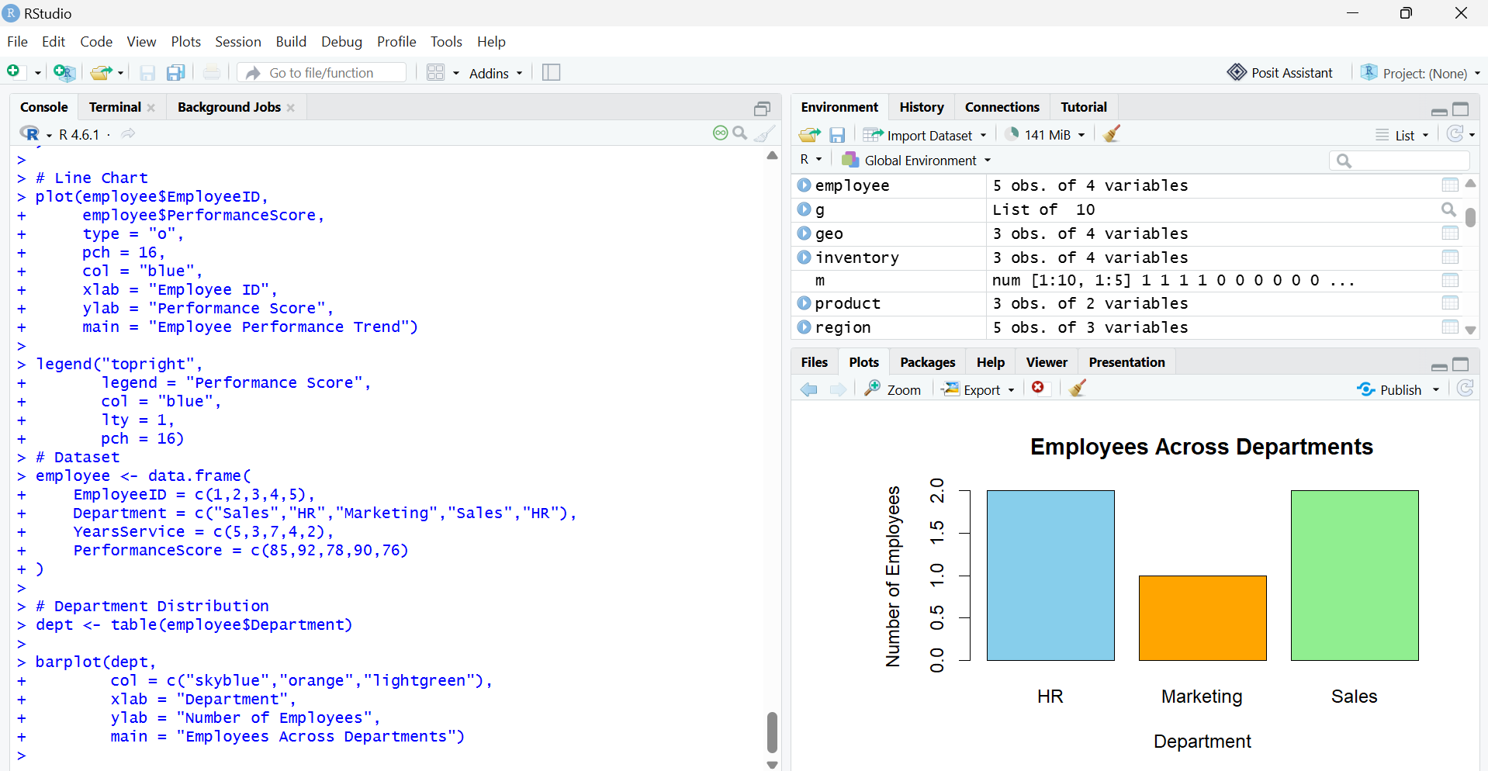

Q3. Scatter Plot
employee <- data.frame(
EmployeeID = c(1,2,3,4,5),
Department = c("Sales","HR","Marketing","Sales","HR"),
YearsService = c(5,3,7,4,2),
PerformanceScore = c(85,92,78,90,76))
plot(employee$YearsService,
employee$PerformanceScore,
pch = 19,
col = "red",
xlab = "Years of Service",
ylab = "Performance Score",
main = "Years of Service vs Performance Score")
text(employee$YearsService,
employee$PerformanceScore,
labels = employee$EmployeeID,
pos = 3)
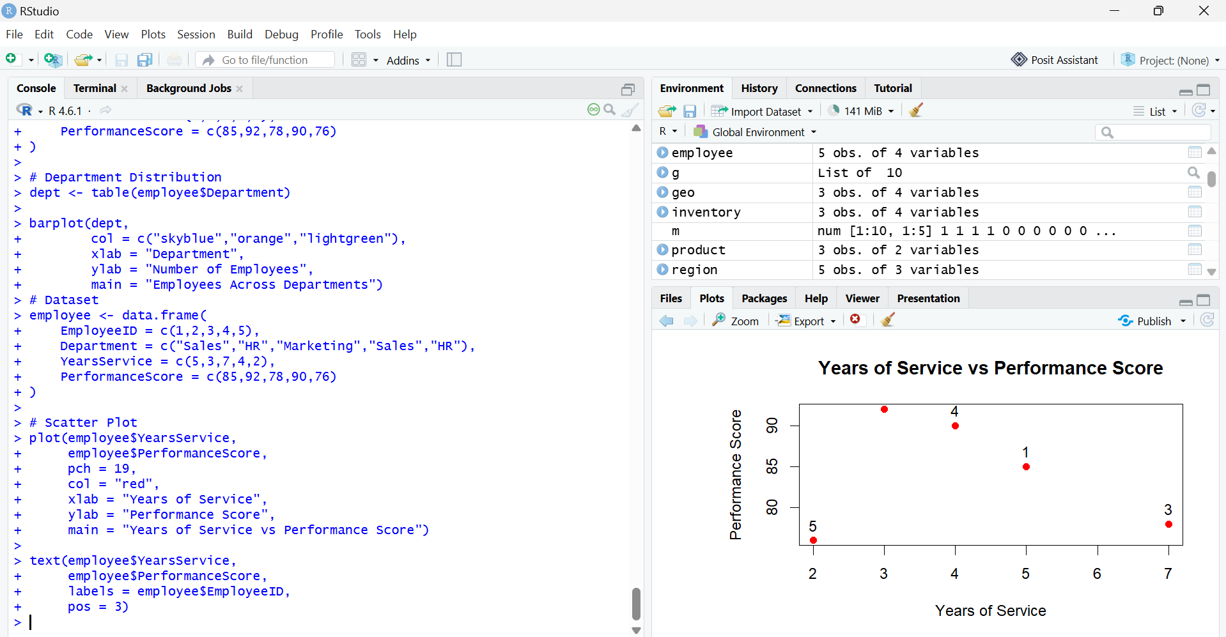

Set 4: Product Inventory Management
1.Create the Dataset Bar Graph
Code:
product <- data.frame(
ProductID = c(1,2,3,4,5),
ProductName = c("Product A","Product B","Product C","Product D","Product E"),
Quantity = c(250,175,300,200,220)
)
Product
barplot(product$Quantity,
names.arg = product$ProductName,
col = "skyblue",
xlab = "Product Name",
ylab = "Quantity Available",
main = "Product Inventory")
Output:
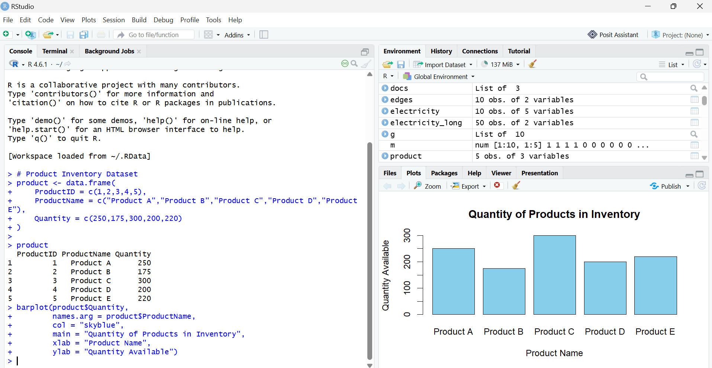

2. Stacked Bar Chart
Code:
product$Category <- c("Electronics","Electronics",
"Furniture","Furniture","Clothing")
qty <- matrix(product$Quantity, nrow = 1)
colnames(qty) <- product$ProductName
barplot(qty,
col = c("red","blue","green","orange","purple"),
main = "Stacked Bar Chart of Product Categories",
xlab = "Categories",
ylab = "Quantity",
legend.text = product$ProductName)
Output:
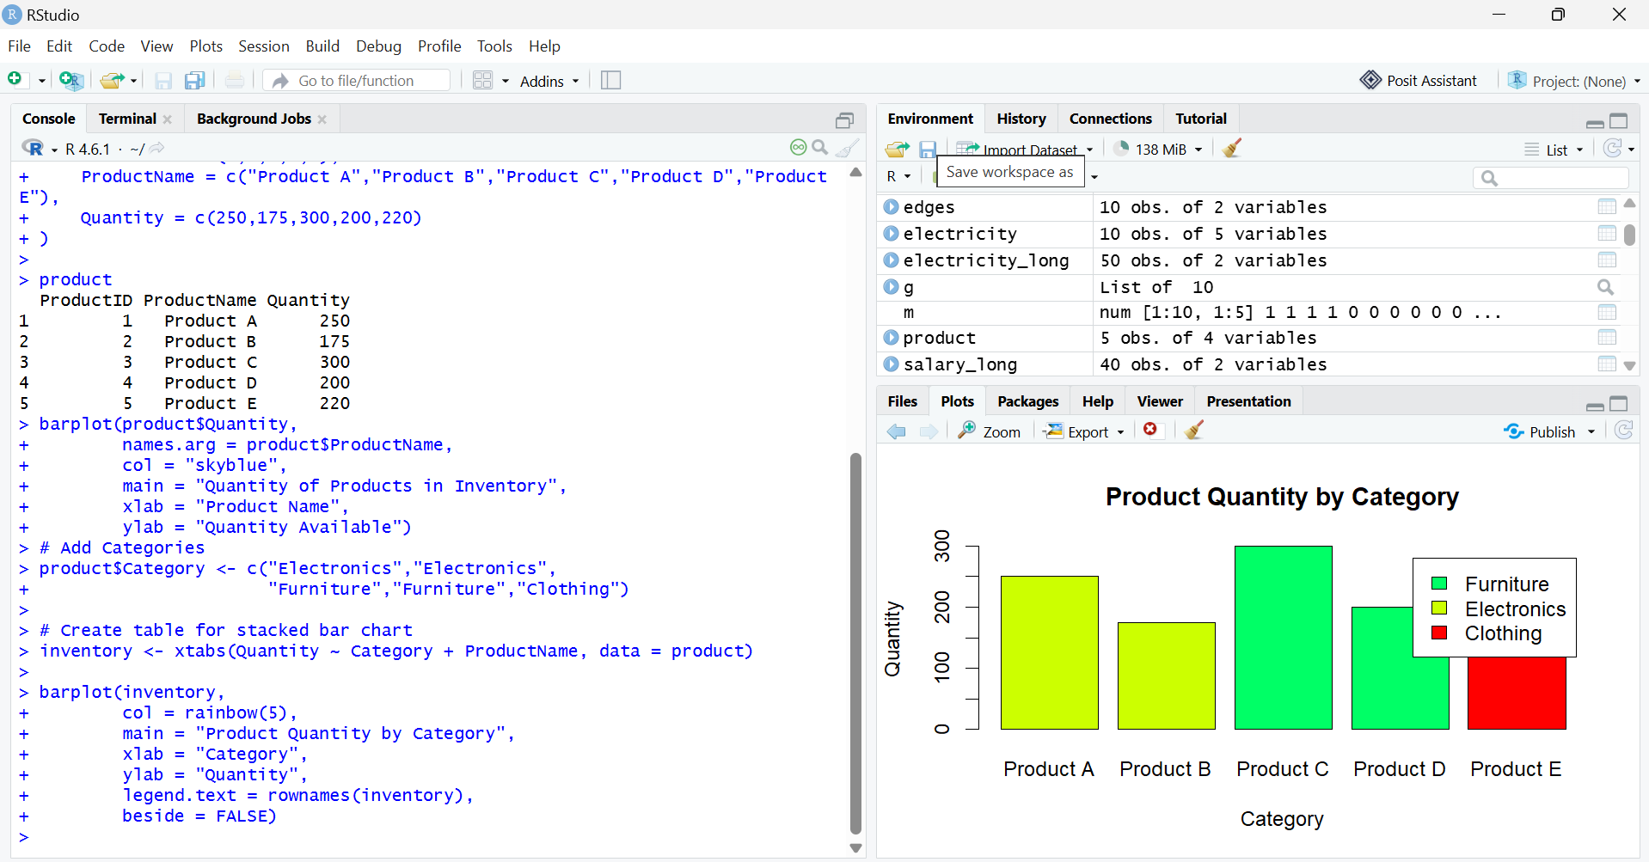

3. Scatter Plot (Price vs Quantity)
Code:
product$Price <- c(500,700,400,650,550)
plot(product$Price,
product$Quantity,
pch = 19,
col = "blue",
main = "Product Price vs Quantity",
xlab = "Product Price",
ylab = "Quantity Available")
text(product$Price,
product$Quantity,
labels = product$ProductName,
pos = 3)
Output:
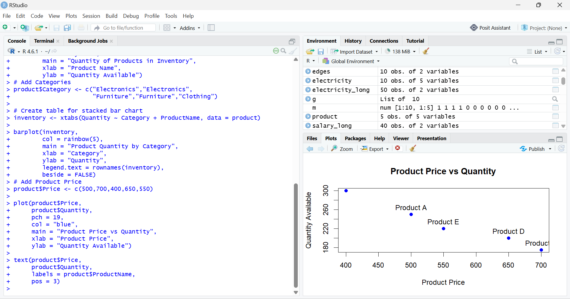

Set 5: Website Analytics
Question 1: Line Chart (Daily Page Views)
Code:
website <- data.frame(
Date = as.Date(c("2023-01-01","2023-01-02","2023-01-03","2023-01-04","2023-01-05")),
PageViews = c(1500,1600,1400,1650,1800),
CTR = c(2.3,2.7,2.0,2.4,2.6)
)
plot(website$Date, website$PageViews,
type = "o",
col = "blue",
pch = 16,
lwd = 2,
xlab = "Date",
ylab = "Page Views",
main = "Daily Page Views Over Time")
Output:
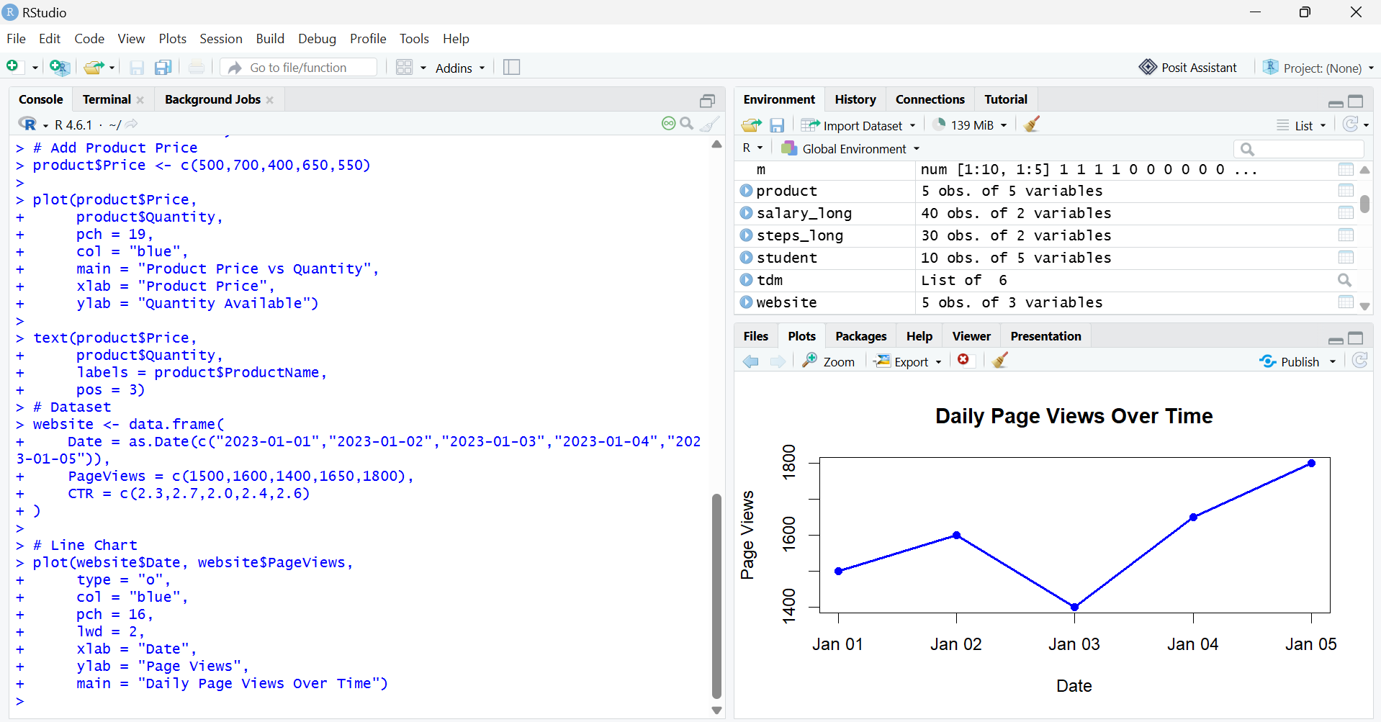

Question 2: Bar Chart (Top 3 Days with Highest CTR)
Code:
website <- data.frame(
Date = as.Date(c("2023-01-01","2023-01-02","2023-01-03","2023-01-04","2023-01-05")),
PageViews = c(1500,1600,1400,1650,1800),
CTR = c(2.3,2.7,2.0,2.4,2.6))
top <- website[order(-website$CTR), ][1:3, ]
barplot(top$CTR,
names.arg = top$Date,
col = "orange",
xlab = "Date",
ylab = "Click-through Rate (%)",
main = "Top 3 Days with Highest CTR")
Output:
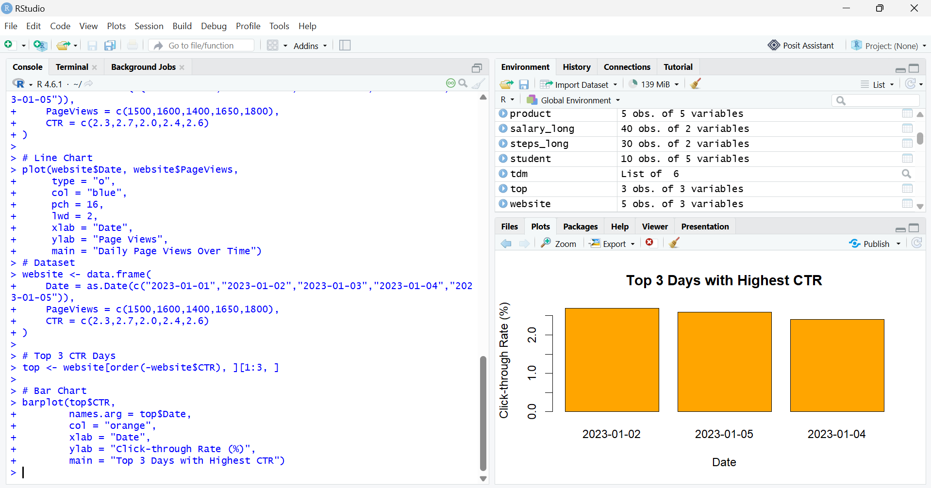

Question 3: Stacked Area Chart (Likes, Shares, Comments)
Code:
date <- as.Date(c("2023-01-01","2023-01-02","2023-01-03","2023-01-04","2023-01-05"))
likes <- c(300,350,280,370,400)
shares <- c(120,150,100,140,160)
comments <- c(80,90,70,85,95)
library(plotrix)
stackpoly(date,
cbind(likes, shares, comments),
col = c("skyblue","lightgreen","pink"),
xlab = "Date",
ylab = "User Interactions",
main = "Stacked Area Chart")
legend("topleft",
legend = c("Likes","Shares","Comments"),
fill = c("skyblue","lightgreen","pink"))
Output:
